

**Kallam Haranadhareddy Institute Of Technology**

**CRM Application That Helps To Book a Visa Slot**

**By**

**Thamatam Harika**

[218x1a4447@khitguntur.ac.in](mailto:218x1a4447@khitguntur.ac.in)

**Korada Hima Tejaswini**

[218x1a4445@khitguntur.ac.in](mailto:218x1a4445@khitguntur.ac.in)

**Chamala Dhathri Varshitha Reddy**

[218x5a4452@khitguntur.ac.in](mailto:218x5a4452@khitguntur.ac.in)

**Mannam Ranga Seshu**

[218x1a4416@khitguntur.ac.in](mailto:218x1a4416@khitguntur.ac.in)

**Project Abstract**

This project aims to develop a CRM-based visa slot booking system to streamline the visa application and appointment scheduling process. The system will enable applicants, visa agents, and embassies to efficiently book slots, reducing wait times and ensuring a smooth application process. Built on Salesforce CRM, the system incorporates automated scheduling, notifications, real-time tracking, and analytics to improve operational efficiency and user experience. A visa slot management project is a system that is used to track and manage the availability of visa slots, which are appointments that are required for certain visa applications. It might be used by a government agency or a visa processing center to schedule and manage appointments with application.

**INTRODUCTION**

### The "CRM Application to Book a Visa Slot" project aims to provide an automated and efficient system for individuals and agencies to book visa appointments easily. The project leverages CRM technology to enhance communication, track application progress, and streamline scheduling for applicants.

### **Objectives**

### **Automate Visa Slot Booking:** Reduce manual intervention and errors in the appointment scheduling process**.**

### **Improve User Experience:** Ensure a hassle-free, transparent, and efficient appointment system.

### **Track Appointment Status:** Provide real-time updates on the status of visa applications.

### **Manage User Data Securely:** Store applicant details safely and ensure compliance with data protection regulations**.**

### **Methodology**

1. **Requirements Gathering:** Conducted surveys and discussions with visa applicants, embassy officials, and agencies to understand their needs.
2. **System Design:** Designed a CRM-based solution with modules for appointment booking, tracking, and communication.
3. **Implementation:** Developed and tested the application using CRM features such as automated workflows, notifications, dashboards, and reports.
4. **Deployment:** Rolled out the application for public use, ensuring scalability and user accessibility.

### 

### **Salesforce Key Features and Concepts Utilized**

To build a robust CRM Application that helps to book a **visa slot**, the following Salesforce features and concepts were implemented:

* **Custom Objects and Fields** – Created objects for Customers, Orders, Transactions, and added custom fields to store relevant data.
* **Lightning App** – Developed a custom Lightning App for easy navigation and a streamlined user experience.
* **Tabs** – Configured tabs for quick access to Customers, Orders, and Reports.
* **Global Picklist** – Standardized values across multiple objects (e.g., Order Status: Pending, Shipped, Delivered).
* **Page Layouts** – Customized layouts to display relevant fields and sections based on user roles.
* **Record Types** – Created different record types for Customer Accounts, Order Categories, and other business cases.
* **User Adoption** – the process of customers or new users getting used to a product or service, it makes a task,ordering food or creating an account, easy.
* **Reports and Dashboards** – Implemented Salesforce Flows to automate processes such as order approvals and follow-up emails.
* **Apex Triggers** – enable you to perform custom actions before or after changes to Salesforce records, such as insertions, updates, or deletions

**Detailed Steps to Solution Design**

**1. Salesforce developer account creation and activation:**

* To create developer org:
* Go to <https://developer.salesforce.com/signup>
* On the sign up form, enter the following details:

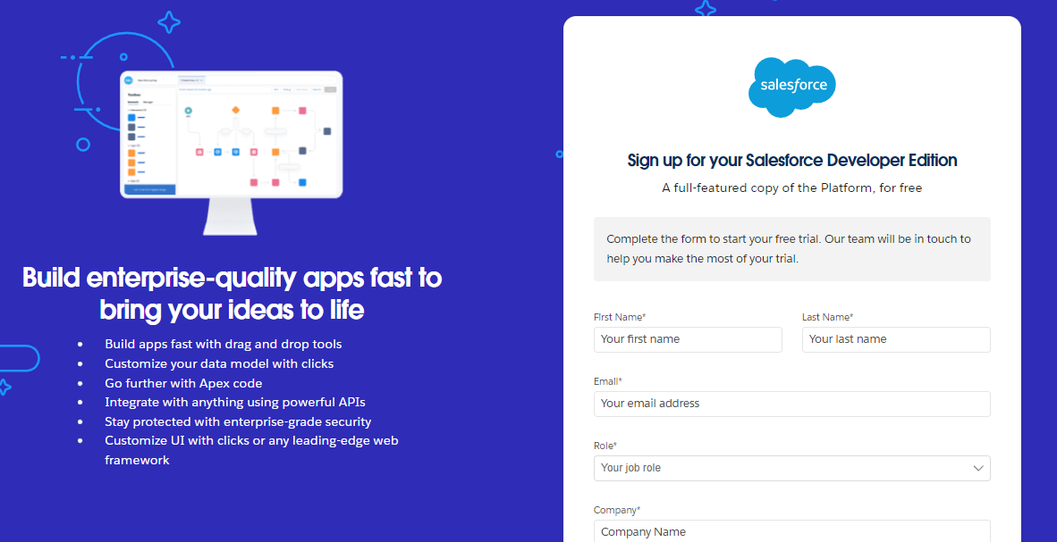

* For account activtion,go to the inbox of the email that you used while signing up. Click on the verify account to activate your account. The email may take 5-10mins.
* Click on Verify Account.
* Give a password and answer a security question and click on change password

|  |  |
| --- | --- |
|  |  |

* Then you will redirect to your salesforce setup page.

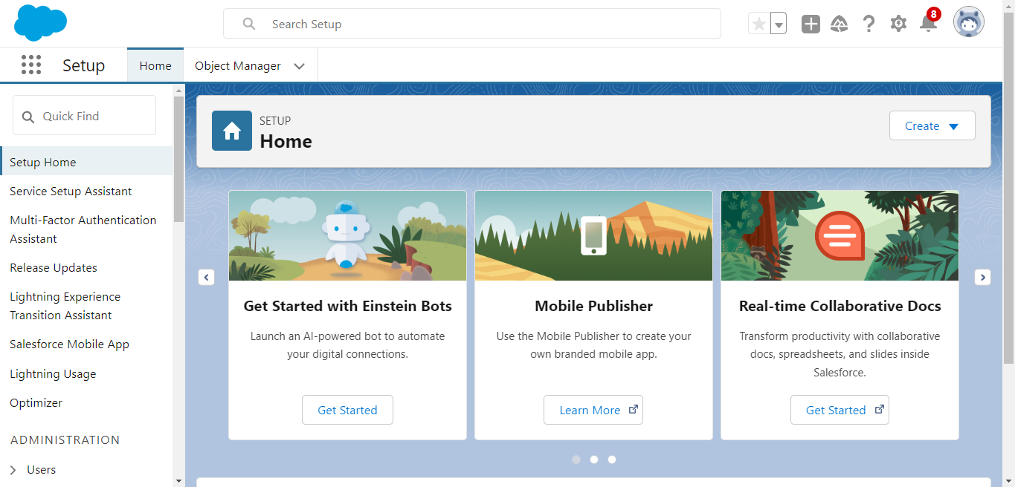

**2. Custom object creation:**

The custom objects that are created are –

* Custom Object-Passport
* Custom Object-Visa Slot
* Custom object-Payment

### To create custom object,

Go to salesforce org and click gear icon. Then go to object manager tab and click create | Custom object.

|  |  |
| --- | --- |
|  |  |

### Label: Passport

### Plural Label: Passports

### Enter Record Name Label and Format

### Record Name:  Passport Number

### Data Type: Text

### In Optional features: check the boxes for Allow Reports

### Search Status: check the box for Allow Search.

### Save

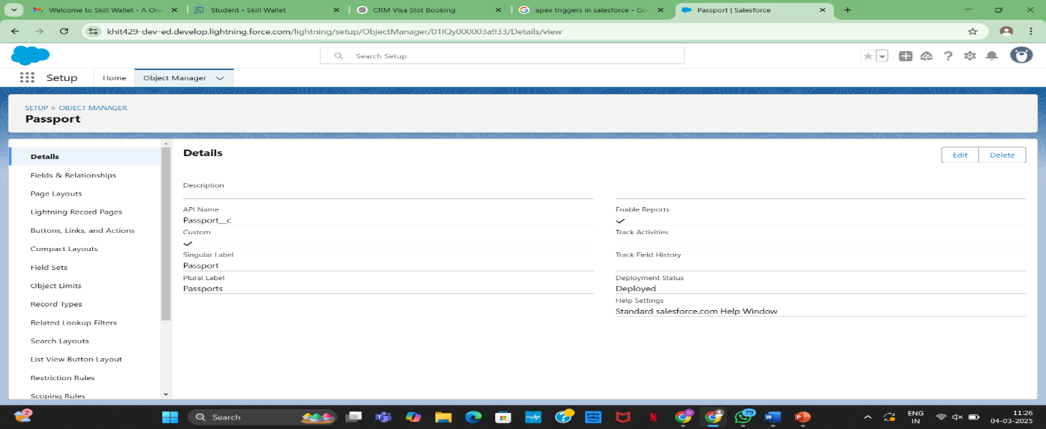

Now repeat the same steps to create custom Visa slot object and Custom Payment object.

**3.Tabs Creation**

* Creation of custom Tab-Passport object
* Creation of custom Tab-Visa slot object
* Creation of custom Tab-Payment object

To create custom tab object

Go to salesforce org and click gear icon Navigate to setup and home,Enter Tabs in Quick Find Box and select Tabs

* Object : Passport
* Tab style : Select any icon
* Leave all defaults as is, Click Next,Next,and Save

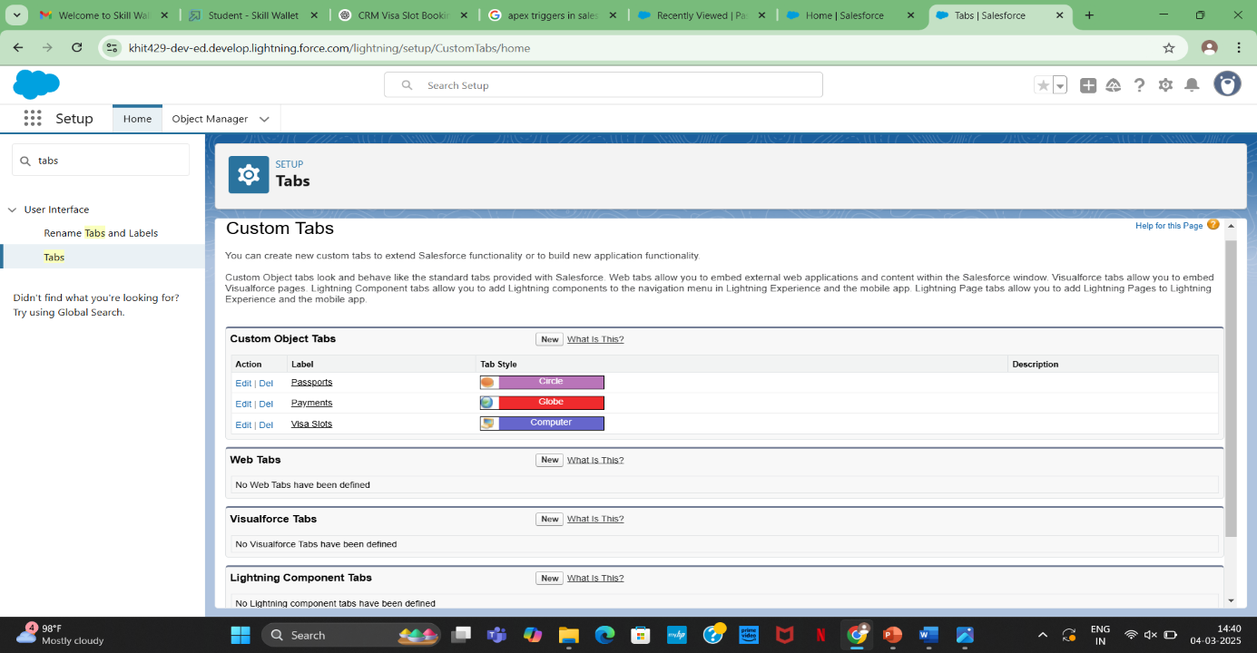

Now repeat the same steps to create custom Visa slot tab and Custom Payment tab.

**4.Relationship Creation**

Relationship in Salesforce is a 2-way association between 2 objects. Using relationships, we can link objects with each other and we can make connections and display data about other related objects.

* To create relationship between 2 objects
* Fields Creation:**Passport Number**
* Navigate to setup
* Click on Object Manager and search and select Visa Slot object
* Select Fields & Relations and click New.
* Select Data Type: **Master-Detail**, next.
* Related to: **Passport**, next.
* Label: **Passport Number**
* Child Relationship Name: Visa Slot, next.
* Next, next and save

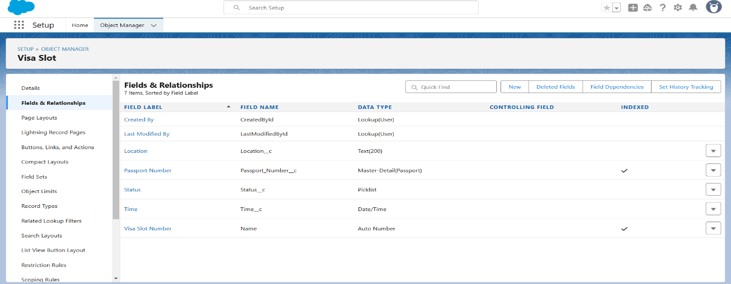

**5.Fields Creation**

**Full Name**

* Navigate to Setup
* Click the Object Manager next to Home Tab
* Type Passport in Quick Find and Select it
* Click on Fields and Relationships
* Click New
* Select Data Type: Text, click on next
* Field Label: Full Name
* Length: Max 80
* Check always requires a value to save this record
* Click next
* Next, Save or Save & New (if further new field will be create)

**Contact Number**

* Navigate to Setup
* Click the Object Manager next to Home Tab
* Type Passport in Quick Find and Select it
* Click on Fields and Relationships
* Click New
* Select Data Type: Number, click on next
* Field Label: Contact Number
* Length: 10 and Decimal 0, click on next
* Next, Save.

**Permanent Address**

* Navigate to Setup
* Click the Object Manager next to Home Tab
* Type Passport in Quick Find and Select it
* Click on Fields and Relationships
* Click New
* Select Data Type: Text Area, click on next
* Field Label: Permanent Address
* Next, next and save

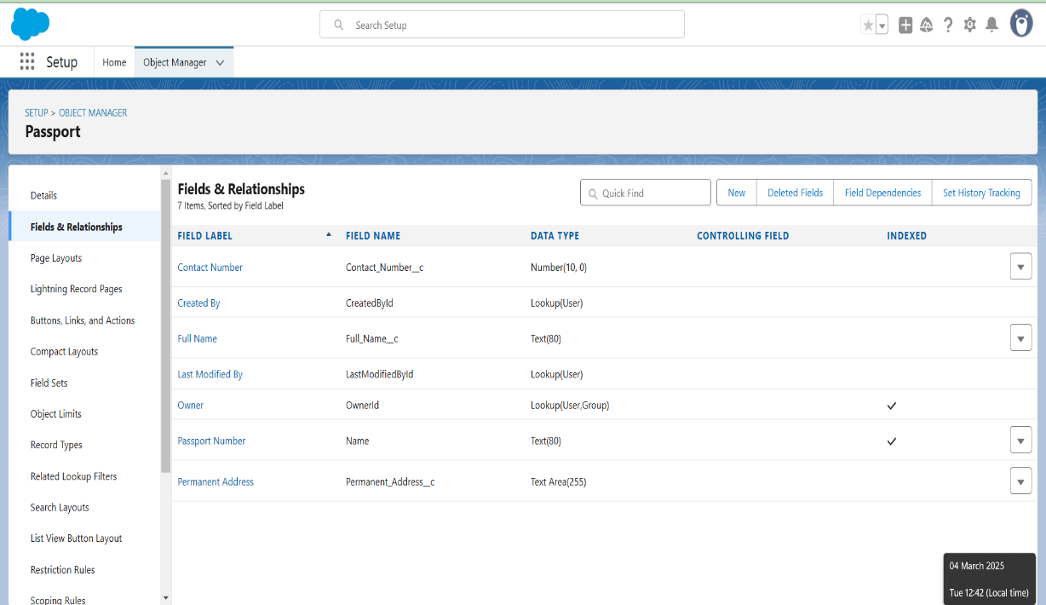

**Custom object: Visa**

* Field Name Data Type
* Location                 Text
* Time                 Date & Time
* Visa Slot Number Auto Number (Use in Record Name)
* Passport Number Master-Detail
* Status                 Picklist

**Status**

* Click on Object Manager, search and select**Visa Slot**
* Click Fields & Relatioships and click on new.
* Chose on picklist, next.
* Label: Status
* NOTE- select enter value, with each value separated by new line
* Values: Approved
* Cancel Reschedule
* Next, next and save.

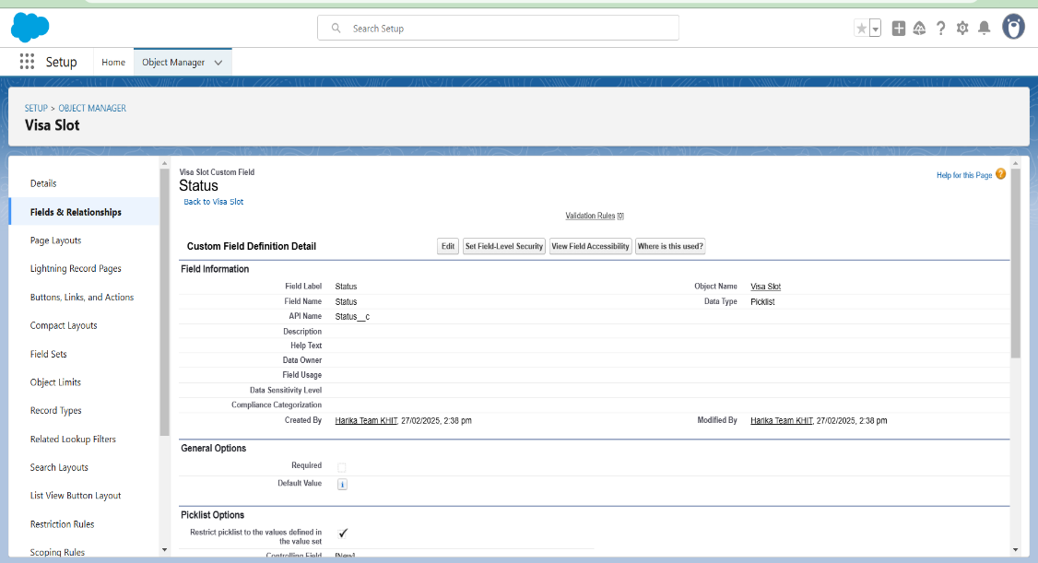

**Field available on custom object: Payment**

* Payment Mode Picklist (Values- Debit Card, Credit Card)
* Card Number       Number.
* Transaction Id Auto Number (Used in Record Name)
* Visa Slot Number Master-Detail
* Cancel Transaction Text

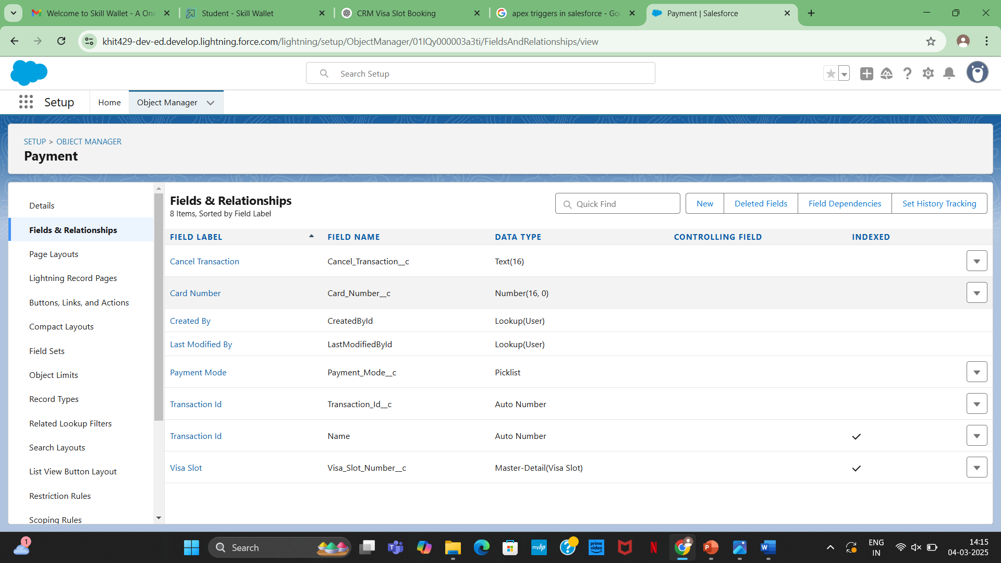

**6.Creation Of App**

* Click on setup and go to home page.
* In Quick Find Box search and select App Manager.
* Click: New Lightning App.
* App Name: Book My Visa and click on next.
* Navigate System: Standard Navigation Support Form Factor: Desktop and Phone Click next, next
* Move Objects from available items to selected items. (Passport, Visa Slot, Payment).
* Add System Administrator profile, available profile to selected profile.
* Save & Finish

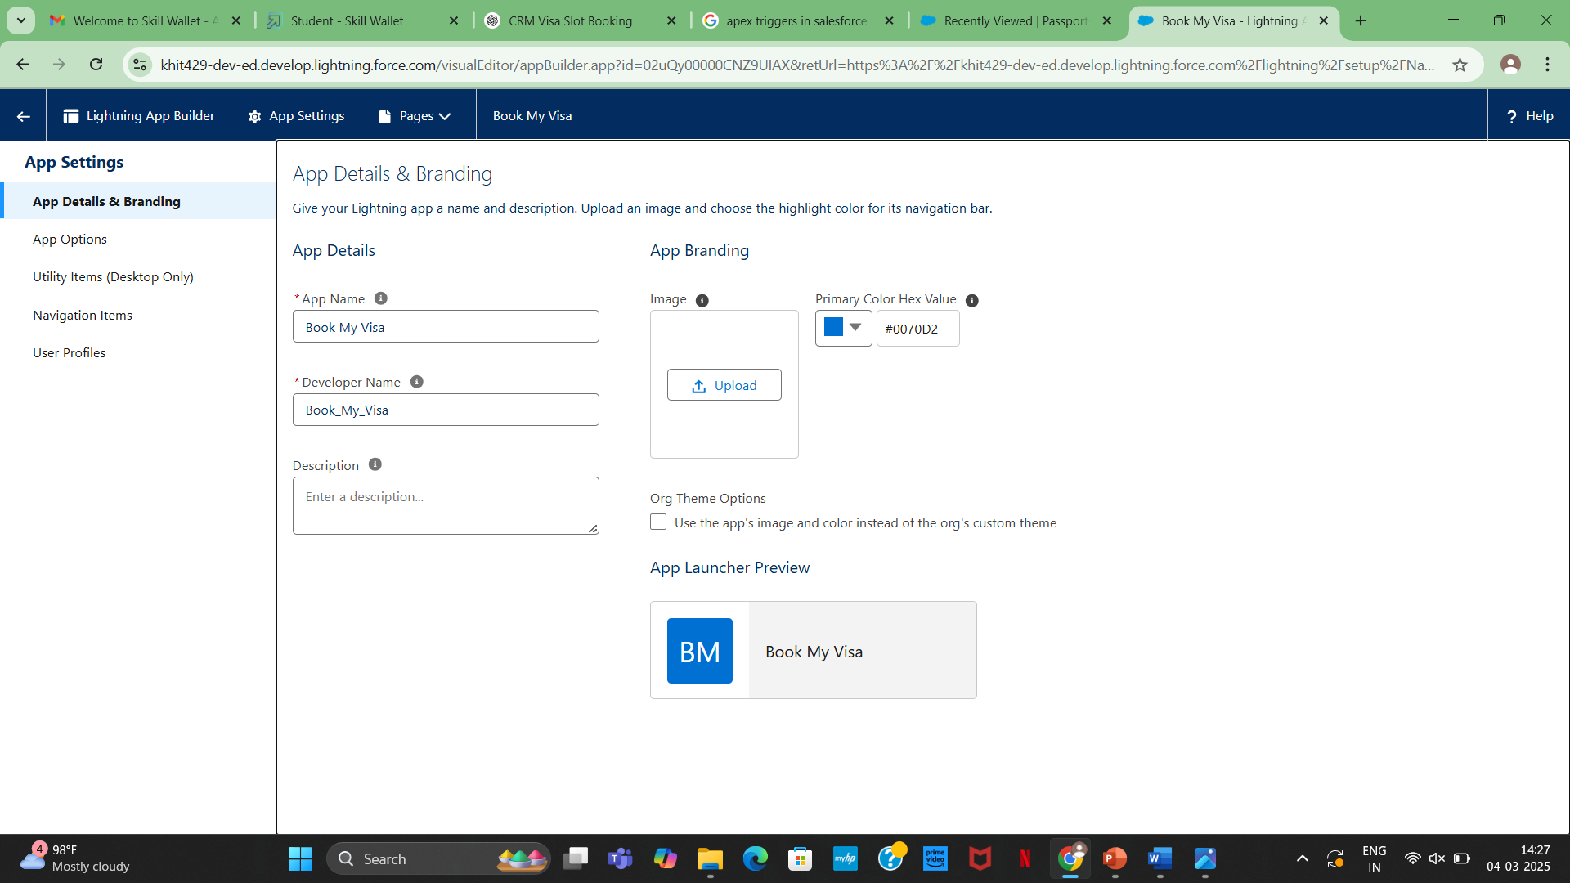

**7.Creation Of User**

* Navigate to setup
* In Quick Find box select and search: User
* Click: New user
* Give First and Last Name
* Enter your email in the email field
* Enter user name, it must be unique
* User license: salesforce platform
* In the profile field: Standard user profile
* Check, Generate new password and notify user immediately
* Save

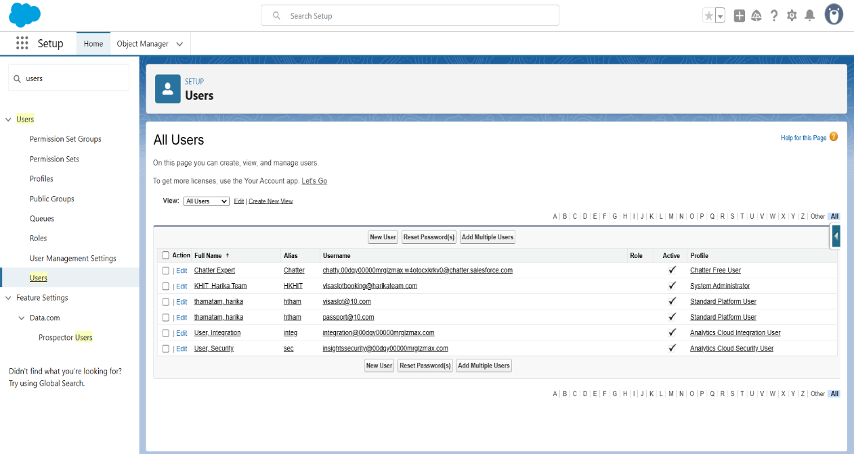

### **Organization Wide Defaults Settings**

* Steps of OWD settings:
* Navigate setup in Quick Find search bar
* Type Sharing Setting and Select it.
* Edit: Organization Wide Defaults.
* Scroll down list and select Passport object and change the default external Access to Public Read/Write.
* Save.

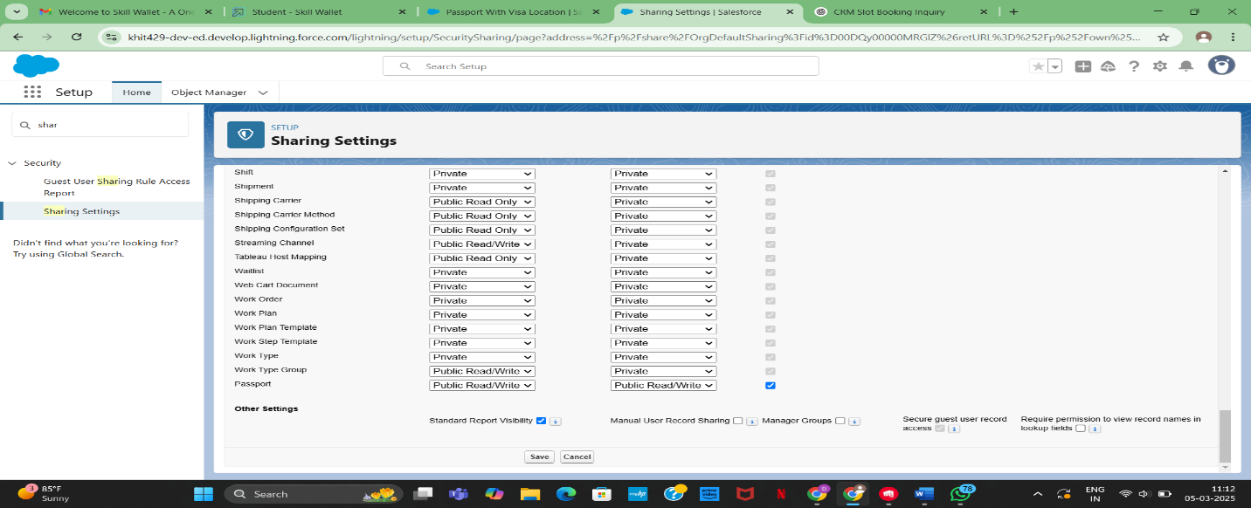

**8.User Adoption**

* Creation of User
* View Record- Passport
* Delete Records- Passport

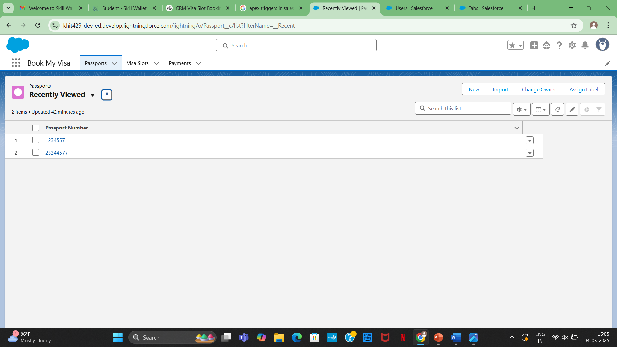

**9.Creation of Report**

Reports in Salesforce is a list of records that meet a particular criterion which gives an answer to a particular question.

* Click on App Launcher left side on the screen, Search and select: Report
* Click Report- select New Report
* Select Report Type: Passport with Visa Slot Number
* Click on Start Report button
* Below the Outline pane- In the Group Row select: Location
* In Group Column select- Passport: Passport Number
* In Column select: Visa Slot Number
* Now navigate to Filter pane available next to Outline pane And ensure in the show me section: All Passport is selected
* In Passport Created date: All Time.
* Give the Label: **Passport with Visa Location**
* Save & Run for saving the Report, Save. 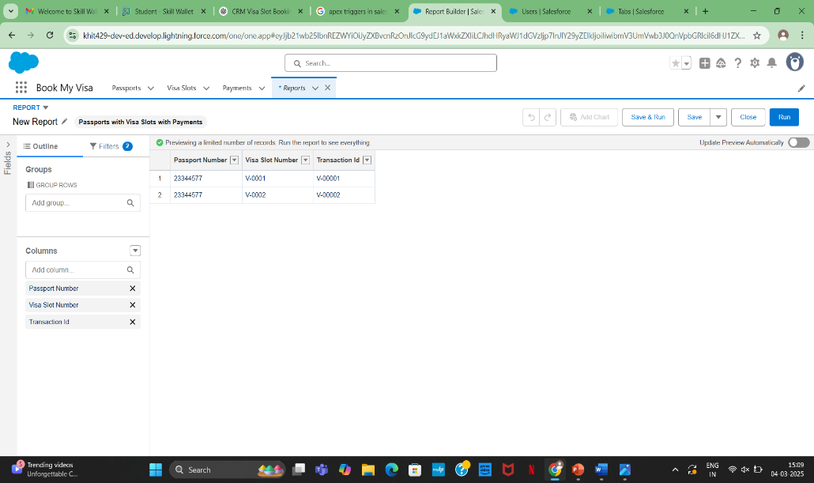

**View Report**

* Click on App Launcher on left side of screen.
* Search Book My Visa App & click on it.
* Click on Reports Tab.
* Click on Passport with Visa Location and see reports.

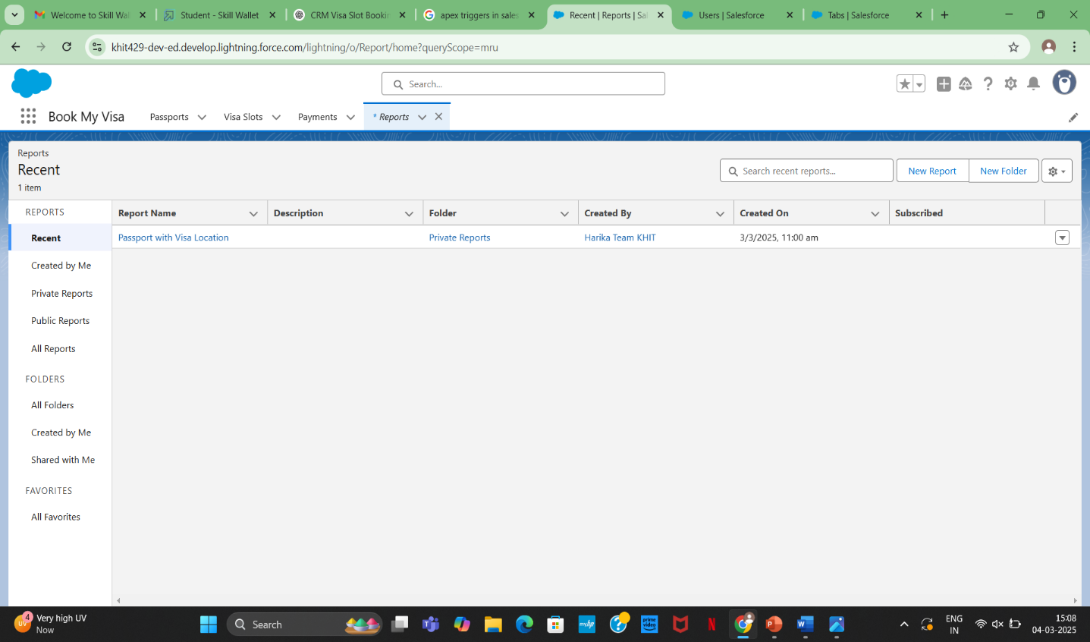

**10.Dashboards**

Dashboards in Salesforce are a graphical representation of Reports. It shows data from source reports as visual components. These components provide snapshots of key metrics and performance indicators of the organization at a glimpse

**Creation of Dashboard**

* Click on the App launcher left on screen and search for dashboards.
* Select New Dashboard
* Name the Dashboard: **Passport With Visa Location**
* Select Create option
* Click on Add Component
* Select **Passport with Visa Locations**
* Click Select
* Select the Donut Chart to display a section
* Value: Record count
* Sliced By: Location
* Leave the default values
* Click on Add
* Save the Dashboard and Done

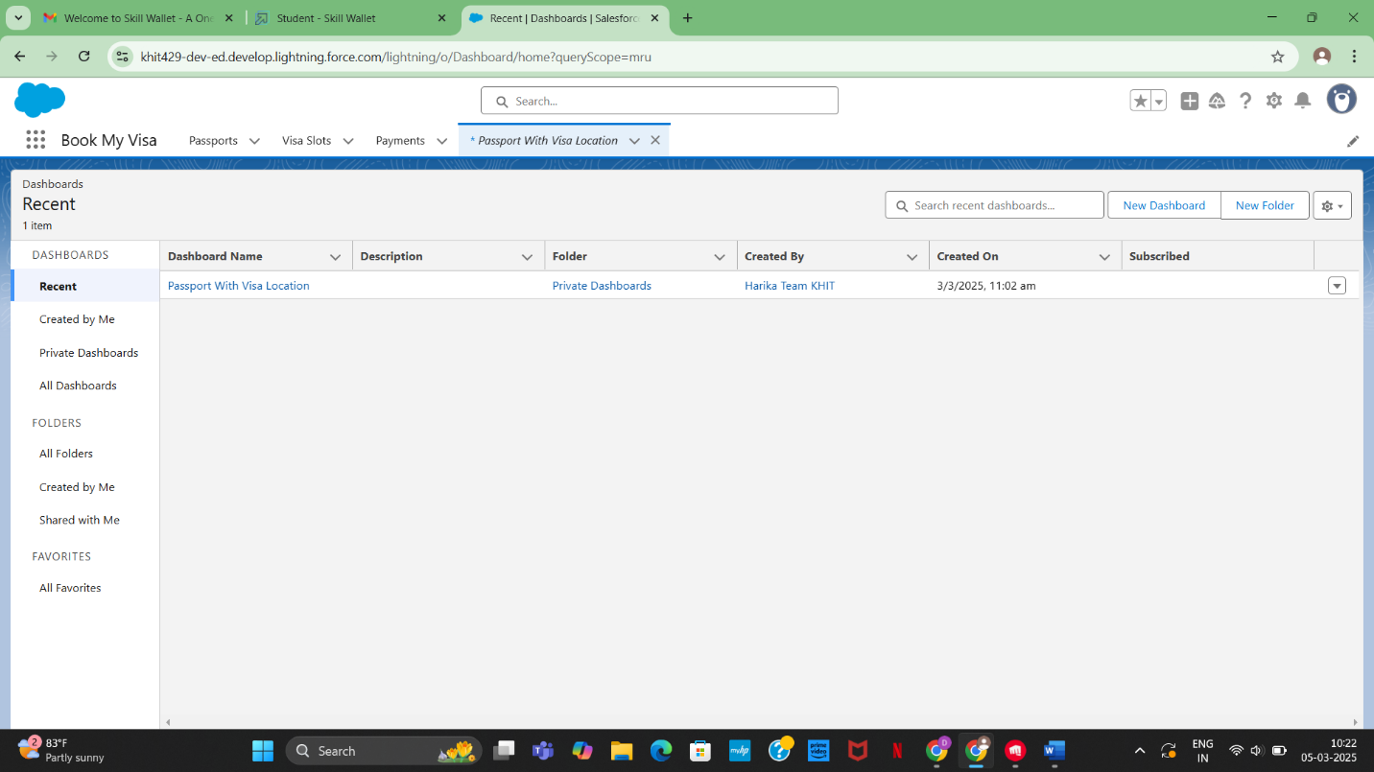

### **View Dashboard**

* Click on App Launcher on left side of screen.
* Search Book My Visa & click on it.
* Click on Dashboard Tab.
* Click on Passport with Visa Location see graph view of record

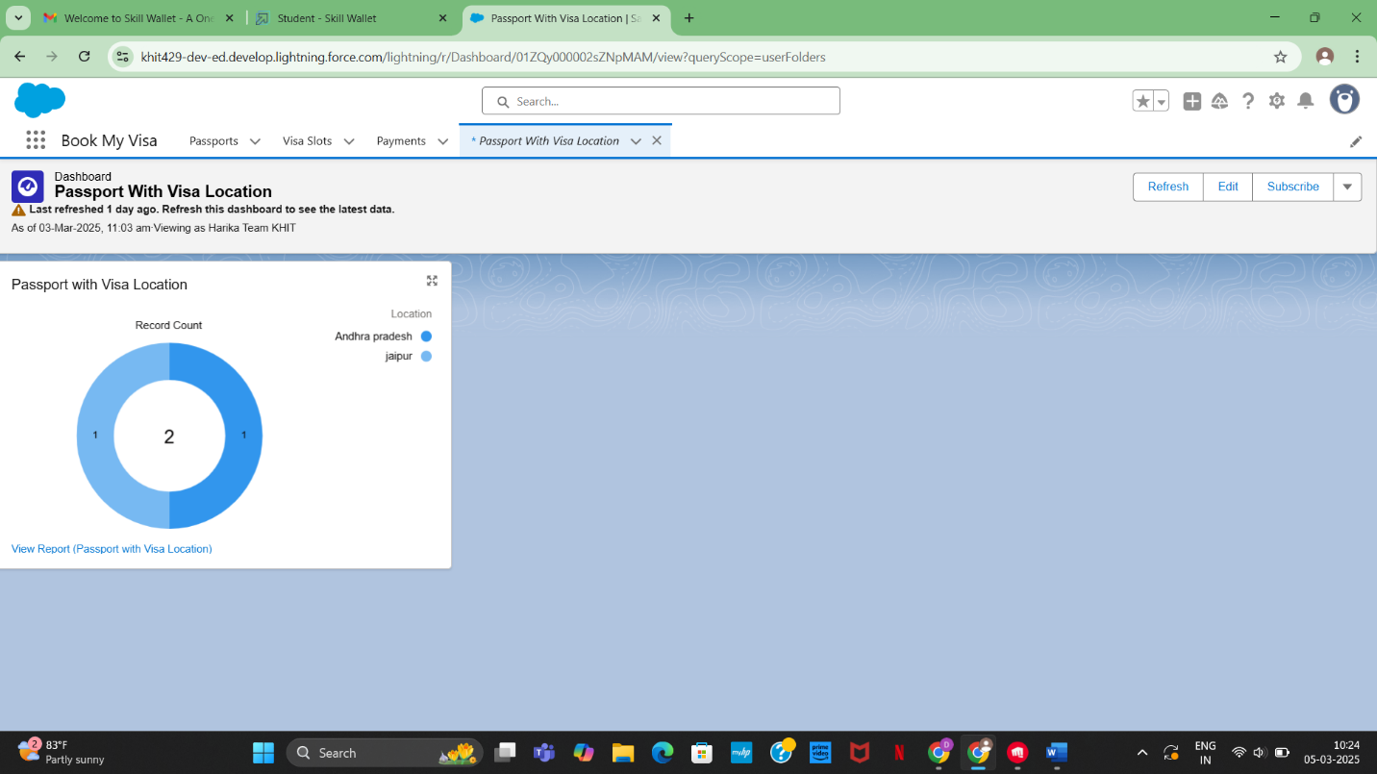

11. **Apex Triggers**

Apex is a coding language of Salesforce. It can be invoked or started using triggers. A trigger is a set of Apex code that runs before or after data manipulation language (DML) events.

**Write a Trigger-1**

* Click on Set up Gear at drop down list you can find developer console click on that.
* At the left side top you can find the option new click on that and then apex trigger.
* Give the name as **Deletionofvisarecord**
* And S object has**Visa Object**
* Scenario - **You cannot delete active visa record**

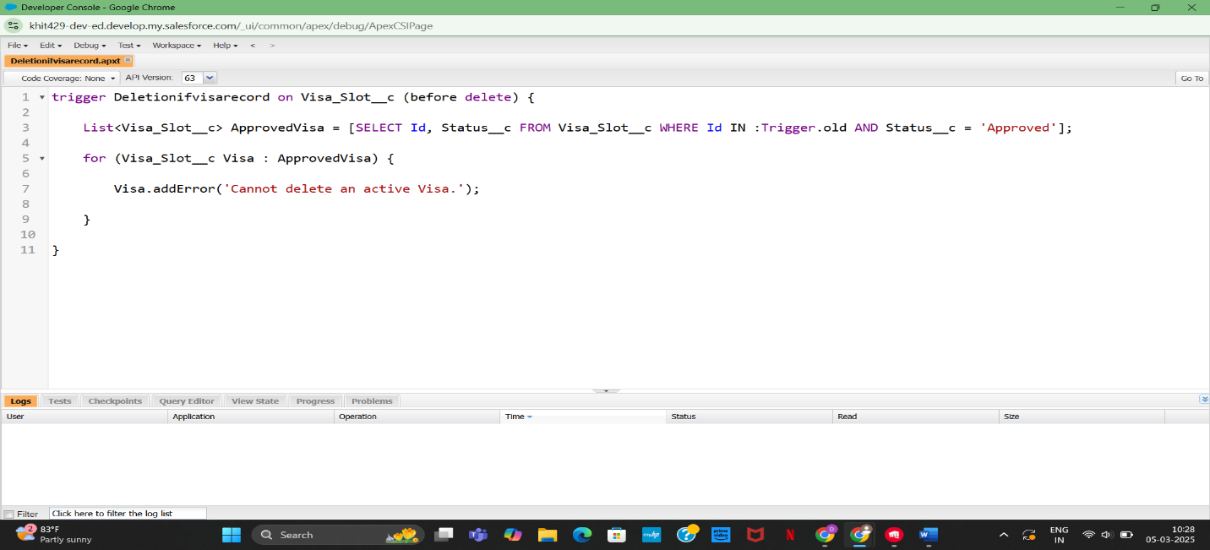

**Write a Trigger-2**

* Click on Set up Gear at drop down list you can find developer console click on that.
* At the left side top you can find the option new click on that and then apex trigger.
* Give the name as AvoidDuplicatePassport
* And S object has **Passport Object**
* Scenario -**trigger on the Passport__c object to avoid duplicate records based on the Full Name and Contact Number fields.**

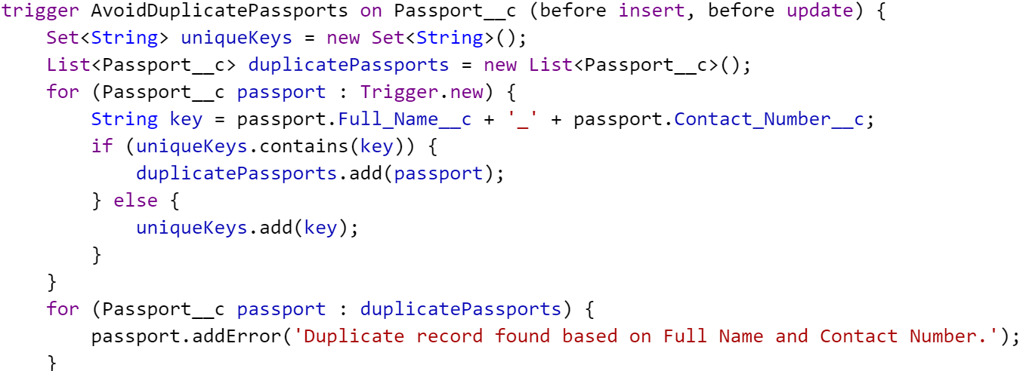

### **Implementation Details**

**Custom Objects**

* **Visa Applicant**: Stores applicant details and visa type information.
* **Visa Slot**: Tracks available appointment slots.
* **Visa Agent**: Manages and assists applicants with booking.
* **Embassy**: Logs embassy details and processing timelines.
* **Slot Booking**: Manages appointment booking details for applicants and agents.

### **Reports and Dashboards**

* **Slot Availability Report**: Displays available slots for booking.
* **Visa Application Status Report**: Tracks application progress.
* **Booking Efficiency Dashboard**: Analyzes successful appointment scheduling.

**Automations**

* **Slot Confirmation Notifications**: Sends alerts upon successful booking.
* **Appointment Reminders**: Notifies users about upcoming slots.
* **Auto-Assignment of Agents**: Assigns visa agents to assist applicants.

### **Outcomes**

* **Efficient Visa Slot Booking:** Reduces delays by providing structured appointment management.
* **Improved User Experience**: Enhances applicant satisfaction through better scheduling.
* **Data-Driven Decision Making**: Provides insights on visa processing trends and booking efficiency.
* **Improved User Experience**: Enhances applicant satisfaction through better scheduling.
* **Data-Driven Decision Making**: Provides insights on visa processing trends and booking efficiency.

**Challenges and Solutions**

* **Challenge**: High demand for limited slots  
  **Solution**: Implemented automated scheduling & waitlists
* **Challenge**: Real-time slot updates  
   **Solution**: Integrated a live booking calendar

### **Future Recommendations**

* **Mobile Application**: Develop an app for easier access and instant booking.
* **AI-Based Predictions**: Use AI to analyze booking trends and optimize availability.
* **Integration with Embassies**: Collaborate with embassies for real-time slot updates.

**Conclusion**

The CRM-based visa slot booking system successfully optimizes the visa application process by providing a structured, automated appointment scheduling system. By leveraging **Salesforce CRM**, automated notifications, and real-time scheduling, the system streamlines operations, making visa slot booking more efficient and user-friendly. The proposed enhancements, including a mobile application and AI-driven analytics, will further improve efficiency and scalability in the future.

**Thank You**